Ques1: Write a Java program to show that private member of a super class cannot be accessed from derived classes.

Source Code

**package** Lab5;

**class** Person

{

String name = "Hitendra";

**private** **float** weight = 70;

}

**class** Student **extends** Person

{

Student(){

System.***out***.println("Inside student class constructor");

}

**int** studentId = 500091910;

}

**public** **class** PrivateMember {

**public** **static** **void** main(String args[]) {

System.***out***.println("Hitendra Sisodia");

System.***out***.println("500091910");

// creation of sub class object

Student obj = **new** Student();

// accessing public members of class

System.***out***.println("Name: "+obj.name);

System.***out***.println("Student Id: "+obj.studentId);

// accessing private members of super class

//System.out.println(obj.weight);

}

}

Output

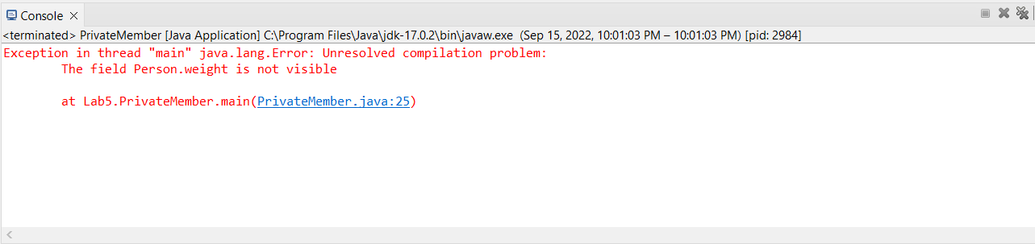

Ques2: Write a program in Java to create a Player class. Inherit the classes Cricket _Player, Football _Player and Hockey_ Player from Player class.

Source Code

**package** Lab5;

**class** Player{

String name;

**int** age;

Player(String name,**int** age){

**this**.name = name;

**this**.age = age;

}

}

**class** Cricket_Players **extends** Player{

Cricket_Players(String name,**int** age){

**super**(name,age); // Used to trigger parent class constructor

}

**void** display() {

System.***out***.println("This is Cricket Player class Extended class from Player");

System.***out***.println("Name: "+**this**.name);

System.***out***.println("Age: "+**this**.age);

}

}

**class** Football_Players **extends** Player{

Football_Players(String name,**int** age){

**super**(name,age);

}

**void** display() {

System.***out***.println("This is Cricket Player class Extended class from Player");

System.***out***.println("Name: "+**this**.name);

System.***out***.println("Age: "+**this**.age);

}

}

**class** Hockey_Players **extends** Player{

Hockey_Players(String name,**int** age){

**super**(name,age);

}

**void** display() {

System.***out***.println("This is Hockey Player class Extended class from Player");

System.***out***.println("Name: "+**this**.name);

System.***out***.println("Age: "+**this**.age);

}

}

**public** **class** Players{

**public** **static** **void** main(String args[]) {

Cricket_Players cp = **new** Cricket_Players("Hitendra",18);

Football_Players fp = **new** Football_Players("Rakesh",19);

Hockey_Players hp = **new** Hockey_Players("Om",19);

cp.display();

fp.display();

hp.display();

}

}

Output

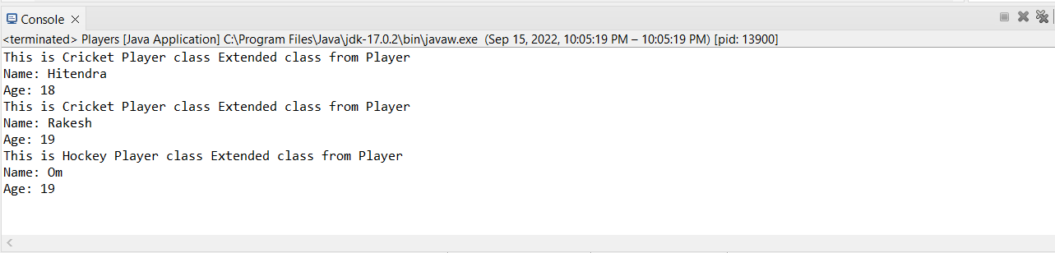

Ques3: Write a class Worker and derive classes DailyWorker and SalariedWorker from it. Every worker has a name and a salary rate. Write method ComPay (int hours) to compute the week pay of every worker. A Daily Worker is paid on the basis of the number of days he/she works. The Salaried Worker gets paid the wage for 40 hours a week no matter what the actual hours are. Test this program to calculate the pay of workers. You are expected to use the concept of polymorphism to write this program.

Source Code

**package** Lab5;

**class** Worker{

String name;

**int** rate = 23;

}

**class** DailyWorker **extends** Worker{

DailyWorker(String name){

**this**.name = name;

}

**void** ComPay(**int** hours) {

System.***out***.println("Daily Worker Week Pay: "+rate*hours);

}

}

**class** SalariedWorker **extends** Worker{

SalariedWorker(String name){

**this**.name = name;

}

**void** ComPay(**int** hours) {

System.***out***.println("Salaried Worker Week Pay: "+40*rate);

}

}

**public** **class** Workers{

**public** **static** **void** main(String args[]) {

DailyWorker d = **new** DailyWorker("Hitendra");

d.ComPay(34);

SalariedWorker s = **new** SalariedWorker("Rakesh");

s.ComPay(34);

}

}

Output

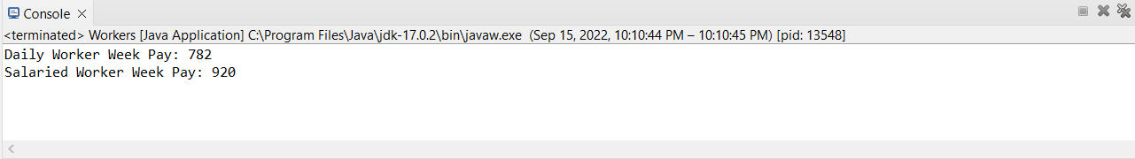

Ques4: Consider the trunk calls of a telephone exchange. A trunk call can be ordinary, urgent or lightning. The charges depend on the duration and the type of the call. Write a program using the concept of polymorphism in Java to calculate the charges.

Source Code

**package** Lab5;

**class** Trunk_call{

//declare the rate of each call

**int** ordinary_rate=3;

**int** urgent_rate=4;

**int** lighting_rate=5;

}

**class** ordinary **extends** Trunk_call{

//methods

**void** charges(**int** hours){

System.***out***.println(**this**.ordinary_rate*hours);

}

}

**class** urgent **extends** Trunk_call{

**void** charges(**int** hours){

System.***out***.println(**this**.urgent_rate*hours);

}

}

**class** lighting **extends** Trunk_call{

**void** charges(**int** hours){

System.***out***.println(**this**.lighting_rate*hours);

}

}

**class** TrunkCalls{

**public** **static** **void** main(String args[]){

ordinary objo =**new** ordinary();

objo.charges(3);

urgent obju=**new** urgent();

obju.charges(4);

lighting objl=**new** lighting();

objl.charges(6);

}

}

Output

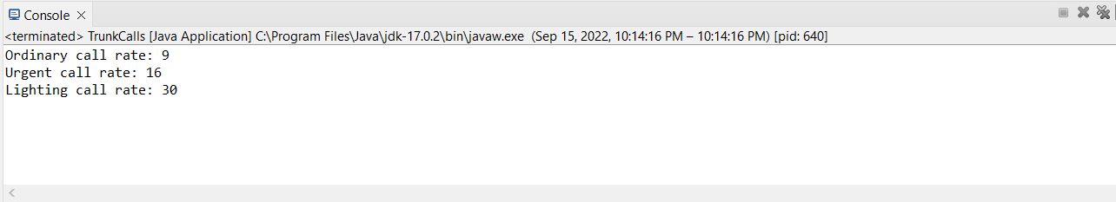

Ques5: Design a class employee of an organization. An employee has a name, empid, and salary. Write the default constructor, a constructor with parameters (name, empid, and salary) and methods to return name and salary. Also write a method increaseSalary that raises the employee’s salary by a certain user specified percentage. Derive a subclass Manager from employee. Add an instance variable named department to the manager class. Supply a test program that uses theses classes and methods.

Source Code

**package** Lab5;

**class** Employee

{

String name;

**int** empid;

**float** salary;

Employee(){

System.***out***.println("This is defulat constructor");

}

Employee(String name,**int** empid,**float** salary){

**this**.name = name;

**this**.empid = empid;

**this**.salary = salary;

}

String get_name() {

**return** **this**.name;

}

**float** get_salary() {

**return** **this**.salary;

}

**void** increaseSalary(**int** perc) {

**this**.salary += (perc/100.0f) * **this**.salary;

}

}

**class** Manager **extends** Employee{

String department;

Manager(String dep){

**this**.department = dep;

}

}

**public** **class** Employees {

**public** **static** **void** main(String args[]) {

System.***out***.println("Hitendra Sisodia");

System.***out***.println("500091910");

Employee e1 = **new** Employee("Hitendra",500091910,1000000f);

System.***out***.println("Name: "+e1.get_name());

System.***out***.println("Salary: "+e1.get_salary());

e1.increaseSalary(20);

System.***out***.println("Salary: "+e1.get_salary());

Manager m1 = **new** Manager("Om");

}

}

Output

